**AIM Analysis Pyhton Script MOP**

**Introduction**

Script will perform the data transformation and filter out the required data from TT_dump and AIM_dump into one output excel file for each iteration on the nodes.

This automation Script will reduce the initial manual work from 7 days to 1 day for each iteration.



Tested for below regions:

NESA

Rajasthan

Tamil Nadu

**Configure your system**

1. [Download](https://www.anaconda.com/products/individual) Anaconda in your system and install it.

(Choose the version as per your system.)

1. Open Anaconda cmd prompt and run the following command

* pip3 install pyxlsb

**Prerequisite**

* Copy all script (5 files) into one location i.e. Parent Directory.

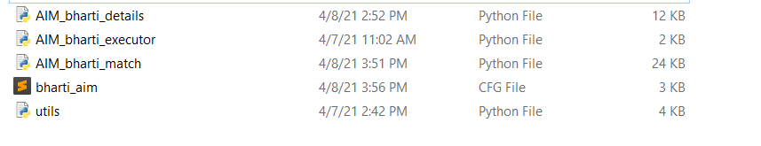

* Create an Input folder and an output folder in the same parent directory.
* Input and Output directory structure given below.
* All the input files are need to be placed in their respective Node_name>Date directory.
* Make sure to give correct path for each of the input files into the config file i.e. (Incident, Details, TT_dump and node list). More details on it later.
* Do not make any change in any of the .py file.
* You are only required to make changes in bharti_aim.cfg file.
* Only variables mentioned below needs to be changed rest must remain untouched for the validity of the script.

**Preparing Input Data**

* Make sure that there is no filter applied in any of the input files. Otherwise there will be inconsistency in the output data

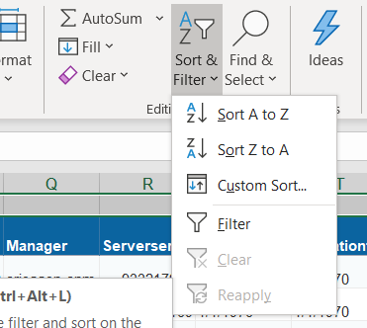

* Make sure that there are no empty rows in the beginning inside any of the input file:

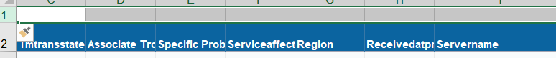

**Note**: In cases like this empty row needs to be deleted

* Now inside the TT_dump you need to copy two columns (Ttclosuretime and Ttcreationtime) into a new excel file. Again, make sure there are no filters applied while copying the data.

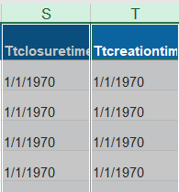

Now All the changes are to be done only inside config file:

**Inside the config file:**

**Input Paths**

You need to give correct path for each of the input file.

Input Data > Node Name* > Date*

All the input files i.e.

* + AIM snapshot
  + TT_dump
  + TT_dump_timedata
  + Node_list

Must be stored in the same directory.

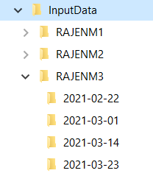

**Configurable variables**

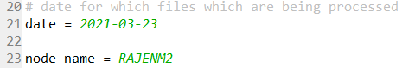

* Here date variable will hold the date you want the data for.
* Then Node variable will hold the node you are working for

The ‘time_diff’ variable will hold the time in minutes as how far back you want to search for the TT and incidents. Currently it is set to 2 hours i.e. 120 minutes.



* The circle variable can be modified to set the region. It can be used to set single region or multiple regions by separating them with a comma as shown below:

z

Next Is AIM snapshots paths:

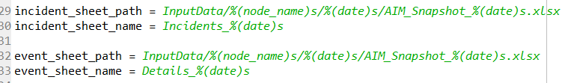

These need not be changed as when you change ‘date’ and ‘node_name’ variable, these values will automatically be updated. Just validate the file name and the sheet name.

Node list file variable:



Check the file name, sheet name and the column name otherwise script will log the error.

TT_dump file variable:

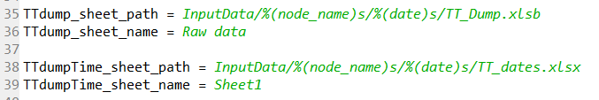

Validate the TT_dump excel path, excel file name with correct extension and sheet name.

Similarly when we copied time data from TT_dump in the beginning, also need to be validated here.

**Output Paths:**

Here you only need to create OutputData directory and the node name then date directory and then all the files inside will be generated automatically inside that directory.

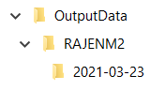

Two final output files will be created in the output directory. One is our output excel file and other is the log file.

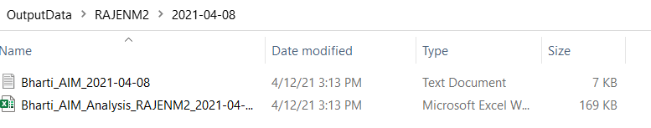

**Limitations**

In sheet TT_summary and TT_matching there is an additional index column which needs to be avoided when copying data from script output to AIM analysis excel file.

Highlighted column **needs to be ignored** from below output sheets:

TT_summary sheet:

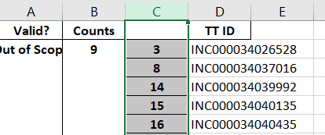

TT_matching column:

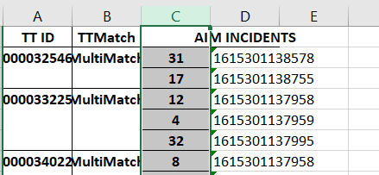

**Steps to Execution**

* Now run the script name **AIM_bharti_executor.py and you will get the data in the output excel file.**
* You can run the file in any editor. But if you have installed Anaconda as suggested above then open Spyder. And run the executor file.
* The **Error Handling** is done in the script such as:
  + No such file or directory means you have given some wrong path in config file please check them again.
  + If there is no data for a particular date script will log that too.
  + If there are empty rows in the beginning of the input file it will throw an error and log it
  + If time data is not copied properly then it might not throw an error but there will be data acquired will be inconsistent.
  + If TT_dump file is of different extensions either ‘.xlsx’ or ‘.xlsb’ script will be able to handle that and execution will be done smoothly.
  + All other input files must be in’.xlsx’ format otherwise script will log an error.
* Every time script is run for the same data the output data will be overwritten but the log files will be appended.

**Sample output and log file:**

